Haley  
Your Healthcare Assistant

For a better quality of life

# Project Summary

‘Haley’ is a one-stop destination for an individual’s complete health monitoring that tracks the most common symptoms in its core. We are designing and implementing a web application which enables a user to record their medical history. Through this platform, we will ask users questions & based on their response, we give them predictions about what ails them. The idea is to develop a reliable and accessible platform that gives user-health advice such that they can avail home remedies and over the counter solutions if the waiting period for GP appointment is long. Additionally, the users will be given a list of General Practitioners based on their location from whom they can get a professional opinion.

‘Haley’ is a health monitoring application that keeps a track of common symptoms to contain the future outbreak by making citizens aware of the impact based on data and sound reasoning such that we can send out an alarm if a lot of people report the same issue in a period of time. Given we aim to make the app accessible to all kinds of user groups; we aim the app to reach everyone.

## The Objective

The goal behind pursuing this project is to provide a reliable platform for the users to keep a track of their health, get an idea of what may be the cause of their discomfort, and manage their symptoms till they find professional help. It will be able to help contain future outbreaks or pandemic like situations by tracking the general health of a population such that an alarm can be sent out if a significant number of people report the same issue in a period of time using the help of available health governance.[1]

The proposed project will solve all the problems that have been identified in the current pandemic including early identification of symptoms and outbreak, availability of scientific data that can be used for research and, reliable information source for the general population.

## The Opportunity

In the current Irish market, there is no application that helps the users to manage their health and symptoms and provide a platform to avoid a big pandemic like the current one. Also, the project helps with getting in touch with GPs around the user’s local area. Finally, we aspire to build a healthy community where we follow the concept ‘each one care one’ with Haley’s assistance.

# PROJECT Development

The minimum viable product for this project will be a working web application which allows the user to-

* Login/Register on the app
* Track his previous medical history
* Check his new symptoms and get a diagnosis.
* Get few home remedies to manage the symptoms as suggested by HSE/WHO.
* Get a list of GPs near his/her location which he can consult.

## Technical/Project Approach

We will be following parallel programming approach for the development phase of the project; we will simultaneously work on the front end and back end section of the project.

* **Front-end UX/UI**

For this we will use the ‘Marvel app’ and ‘JustInMind’ prototyping tool. We will also use HTML, CSS, Bootstrap, and JavaScript/jQuery for it.

* **Business Logic**

For implementing the features, we will use Django, Python, and J2EE.

* **Back-end**

The web application based on the Django environment where deep neural network /machine learning models are run. The models run above the server flask which is integrated with the database. We will be using Mongo DB and SQL for the database.

Both front end and backend components are dockerized as an image inside a container that will deployed on GitHub for use.

## Data Source

The Dataset we will use for this project is obtained by using the combine approach of finding existing datasets and generating new ones. We are getting data from open source repository like Kaggle, GitHub, UCI and Google datasets as well as using real time experience from doctors to synthesize a dataset using java code. The java code ensures the elimination of conscious bias from the dataset. The final dataset contains 49 columns and 10001 rows amounting to 490001 data points. [2]

## Evaluation

To evaluate the performance of the project we will use the following 4 methods-

1. Space complexity- We will measure the bulkiness of the code; this includes the hard coding and the space and power needed to run the code.
2. Time Complexity- Time complexity of the code will be measured by the time taken to populate the pages and results.
3. Confusion Matrix- This will be used to measure the performance of the model by calculating the error rate and false positives.
4. User Feedback- This will be final evaluation point where we will ask the users questions like ‘Was the application easy to use?’, ’How did you like our application?’, ‘Was the app easily accessible?’ etc. we will use this feedback to improve the performance of our app.

# PROJECT management

We will be following the agile methodology which breaks down the project into manageable sprints and scrum. We will also follow the practice of daily stand up meetings and maintain a burn down chart.

## Execution Strategy

We will develop the project in 3 phases-

1. **Development Phase-**

This phase will last for a total of 7 weeks.

We have planned to have 3 sprints in this project, each sprint is divided into a certain number of scrums (each scrum is 1 weeklong).

The outcome of each sprint is as follows-

|  |  |  |  |
| --- | --- | --- | --- |
| Sprint | No. of Scrums | Deliverables | Duration |
| 1 | 2 | POC of the project | 2 weeks |
| 2 | 3 | Minimum Viable Project | 3 weeks |
| 3 | 2 | Scaled enterprise level project | 2 weeks |

1. **Testing and User Evaluation Phase-**

This phase will last for 2 weeks.

In this phase we will test our application against several users and different input sets of symptoms to check the results of our model. This phase will also be used to analyze the results with respect to our confusion matrix.

1. **Deployment Phase-**

This phase will last 2 weeks. In this phase we will make the web app available to use, also we will write the final report for the project and prepare the presentation/Demo.

## Project Deliverables

|  |  |
| --- | --- |
| Deliverable | Description |
| Web Application | This is the deployed application which can be access through internet to everyone. |
| Project Report | The final report including the technical and non-technical aspect of the project as well as the conclusion. |
| Project presentation | The show and tell of the project done by the actors. |
| Zip file | Zips file containing all the deliverables including the code, report, and presentation. |

## Timeline for Execution

The total duration allotted to the group project is that of 13 weeks. As mentioned earlier we are dividing the project into 3 phases which amounts to a total of 12 weeks, the remaining 1 week is the buffer which we have allocated to the project.

Please find the Gantt chart shows a clearer picture of the timelines-

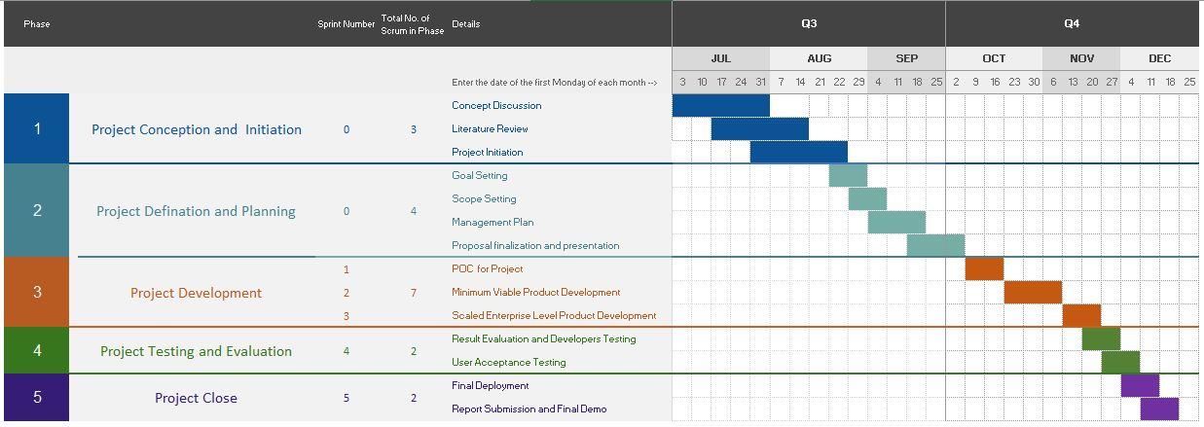

*A clearer picture of this Gantt chart can be found in the attached excel below

## 

## Success

Success for us can be defined as the following

1. Adhering to timelines
2. Delivering a fully functioning project with all the features
3. A fulfilling and harmonic collaboration between all the actors in the group
4. A good final demo/ presentation and report.

## Stakeholders

|  |  |  |
| --- | --- | --- |
| Name | Email | Role |
| Geetika Agarwal | D18128873@mytudublin.ie | Data Scientist / Full Stack Developer (Agile) |
| Vaibhav Naran Gala | D18130272@mytudublin.ie | Data Scientist /Developer (Agile) |
| Ayushi Nayak | D19123831@mytudublin.ie | Software Engineer / Full Stack Developer (Agile) |
| Avinash Peruboina | D19123919@mytudublin.ie | Software Engineer / Full Stack Developer (Agile) |
| Hassan Yaqoob | D18130130@mytudublin.ie | Software Engineer / Full Stack Developer (Agile) |
| Damian Gordon | Damian.x.Gordon@TUDublin.ie | Mentor |
| Andrea Curley | andrea.f.curley@TUDublin.ie | Mentor |
| Paul Kelly | paul.kelly2@tudublin.ie | Mentor |

# References

1. <https://github.com/adalca/medical-datasets>
2. <https://www.kaggle.com/itachi9604/disease-symptom-description-dataset>
3. <https://hpo.jax.org/app/download/annotation>
4. <https://github.com/leanderme/sytora>
5. <https://www.kaggle.com/plarmuseau/sdsort/home>
6. <https://www.kaggle.com/plarmuseau/primer>
7. <https://www.kaggle.com/plarmuseau/symptom-disease-recommender>
8. <https://github.com/Aniruddha-Tapas/Predicting-Diseases-From-Symptoms>
9. <https://themanifest.com/mobile-apps/how-develop-healthcare-app>
10. <https://www.malacards.org/>
11. <https://www.kaggle.com/moradnejad/nhanes-questionnaires-datasets-20172018-csv>?
12. <https://www.kaggle.com/johnsmith88/heart-disease-dataset>
13. <https://www.kaggle.com/mansoordaku/ckdisease> <https://www.kaggle.com/priya1207/diseases-dataset>
14. <http://ecg.mit.edu/time-series/>
15. <https://archive.ics.uci.edu/ml/datasets/Statlog+%28Heart%29>
16. <https://physionet.org/data/>
17. [http://47.93.42.104/544#](http://47.93.42.104/544)
18. <https://ada.com/>
19. <https://github.com/GroupProjectSem3/synthea>

# APPENDIX

**Haley System Context Diagram**

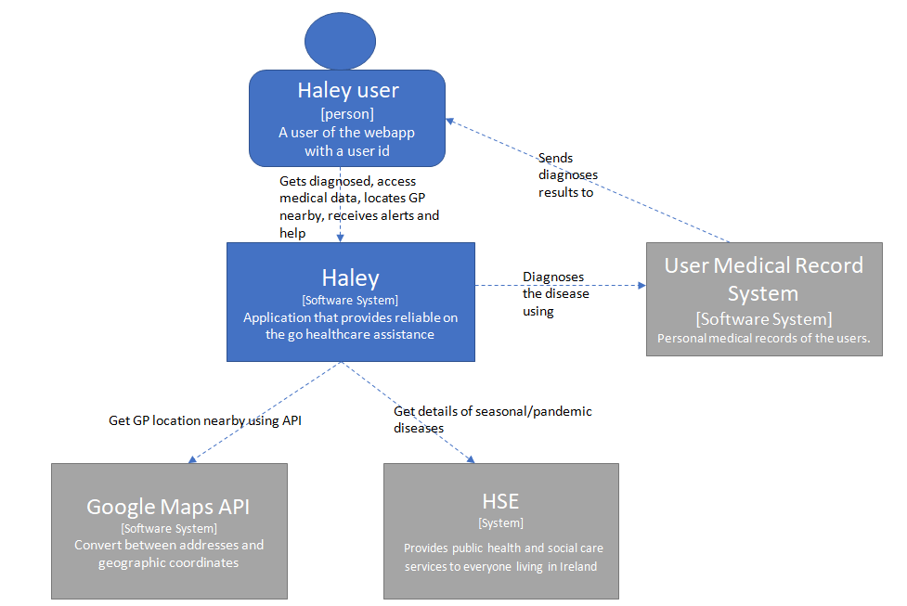

**Haley Webapp Container Diagram**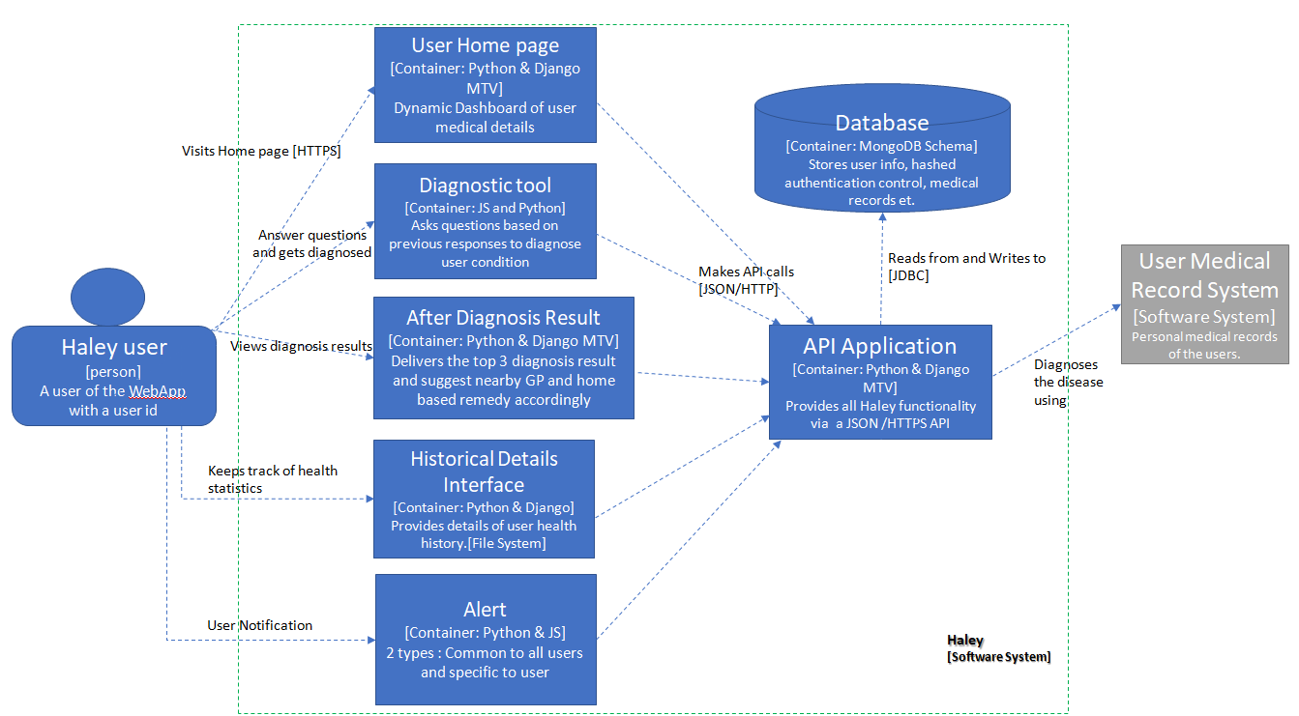

**Component Diagram for Haley Webapp – User Home Page**

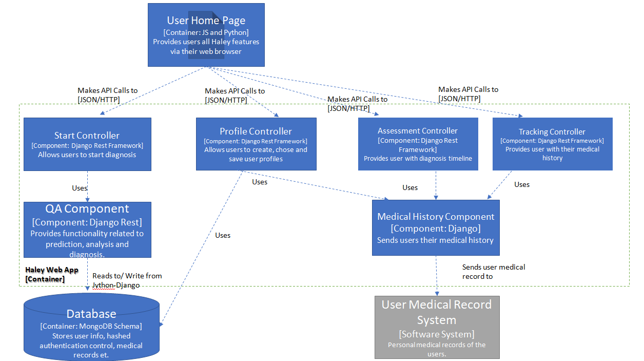

**Component Diagram for Haley Webapp – Diagnostic Tool**

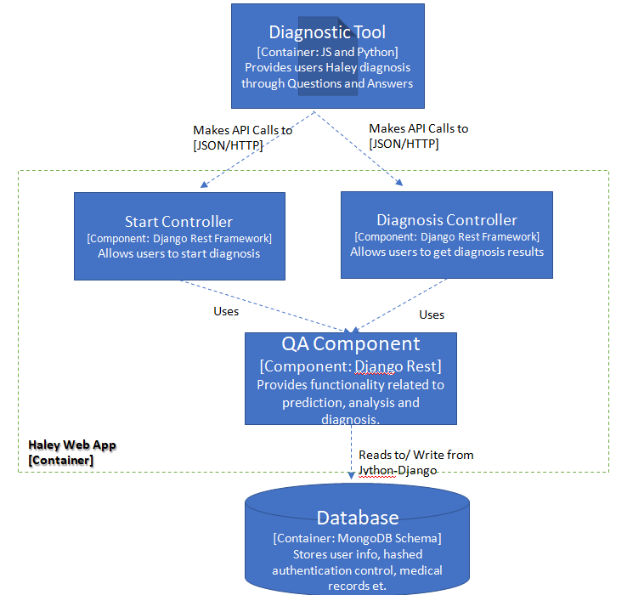

**Component Diagram for Haley Webapp – After Diagnostic Result**

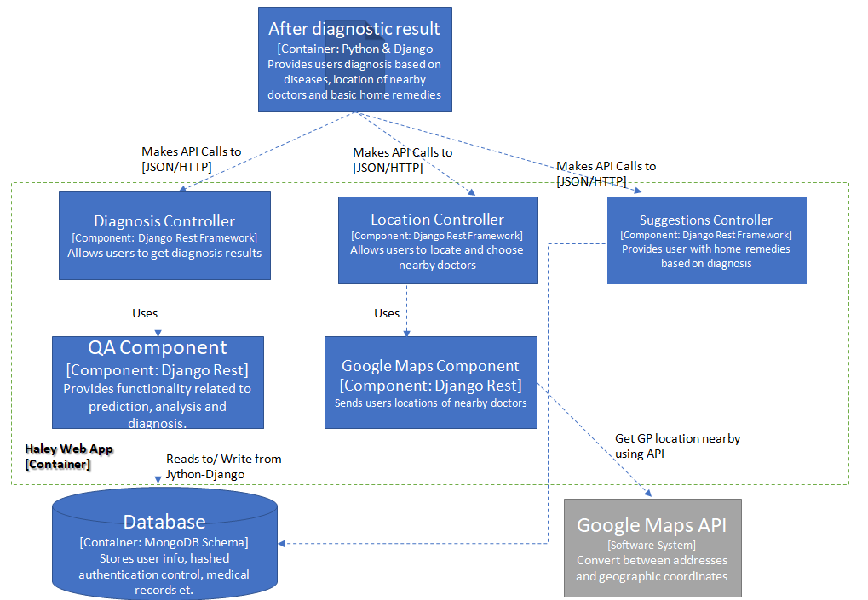

**Component Diagram for Haley Webapp – Historical Details**

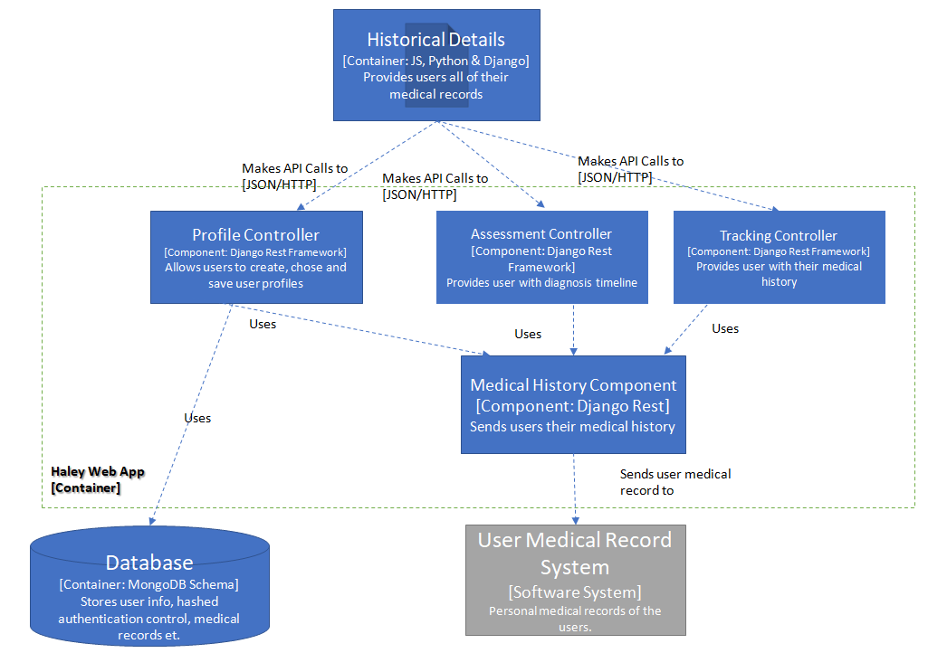

1. <https://www.hse.ie/eng/>

   <https://www.nhs.uk/>

   <https://www.nhs.uk/using-the-nhs/about-the-nhs/your-health-records/>
2. <https://www.kaggle.com/priya1207/diseases-dataset>

   <https://www.kaggle.com/moradnejad/nhanes-questionnaires-datasets-20172018-csv>?

   <https://www.kaggle.com/johnsmith88/heart-disease-dataset>

   <https://www.kaggle.com/mansoordaku/ckdisease>

   <https://github.com/adalca/medical-datasets>